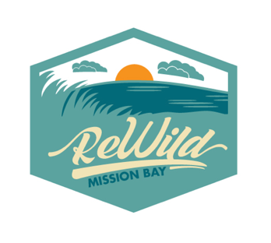

OP/ED and LTE TEMPLATE
If you want to get active and let the decision-makers know that the community is speaking in support of Wildest wetland restoration, then write a quick note to your local paper or share on social media--get the word out that you support ReWild Mission Bay!

To get started, research 2-3 local newspapers. Typically, letters to the editor are between 150 and 250 words. If your letter is too long, there is a very high likelihood it will not be accepted.

Here's some ideas for your op-ed, letter, or post:

Dear Editors,

I am a strong advocate for ReWild Mission Bay, and I urge the City of San Diego to support the Wildest wetland restoration. A project of the San Diego Audubon Society, ReWild Mission Bay was founded in 2014 to advocate for tidal wetland restoration in the northeast corner of Mission Bay. Along with reconnecting the surviving remnant of the bay’s once vast wetlands at Kendall-Frost Marsh Reserve with its fresh water source at Rose Creek, restoration of wetland ecosystems in northeast Mission Bay will also result in:
ADD OR EXPAND ON THE POINTS YOU ARE MOST PASSIONATE ABOUT
· Cleaner water in Mission Bay, as wetlands will naturally filter and improve the water quality that enters the bay from Rose Creek and nearby storm drains, resulting in a healthier bay and safer recreation opportunities.
· Greater public access to our shared shoreline within Mission Bay Park.
· Greater climate resiliency against rising sea levels.
· Opportunities for Indigenous Kumeyaay communities to serve as regional stakeholders and reconnect with historic sites along Mission Bay.
· A potential for low-cost camping options managed by the city or a contracted vendor.
· Restoration of the world’s best mechanism for sequestering carbon, as salt water marsh wetlands hide away carbon even more effectively than old-growth rainforests.

The City is about to release a new land use plan for the ReWild area, and it should have the same goals as the ReWild Wildest wetland restoration proposal. Our city leaders have an opportunity to lead the City toward the best result, and revitalize a public park to be ready for the challenges of the next 100 years and future generations of residents and visitors. This is a once-in-a-generation opportunity to reimagine this corner of Mission Bay as a regional recreational, ecological, educational, and research destination.

MAKE THIS REFLECT YOUR HOPE FOR WHAT THE CITY DOES
Please support the ReWild Wildest proposal and show your support at an Environment Committee meeting focused on the City’s opportunity to lead on climate change and equitable access action in Mission Bay.

Sincerely,
SIGNATURE, NAME, ORGANIZATION, AGE OR SCHOOL

